- The Asset Health section is showing inconsistent behavior. For example, Air Compressor A1 and Air Compressor B1 display different sets of parameters. Since both assets belong to the same equipment type (compressors), they should ideally have a consistent set of monitoring parameters for accurate comparison and analysis.
Air Compressor A1:
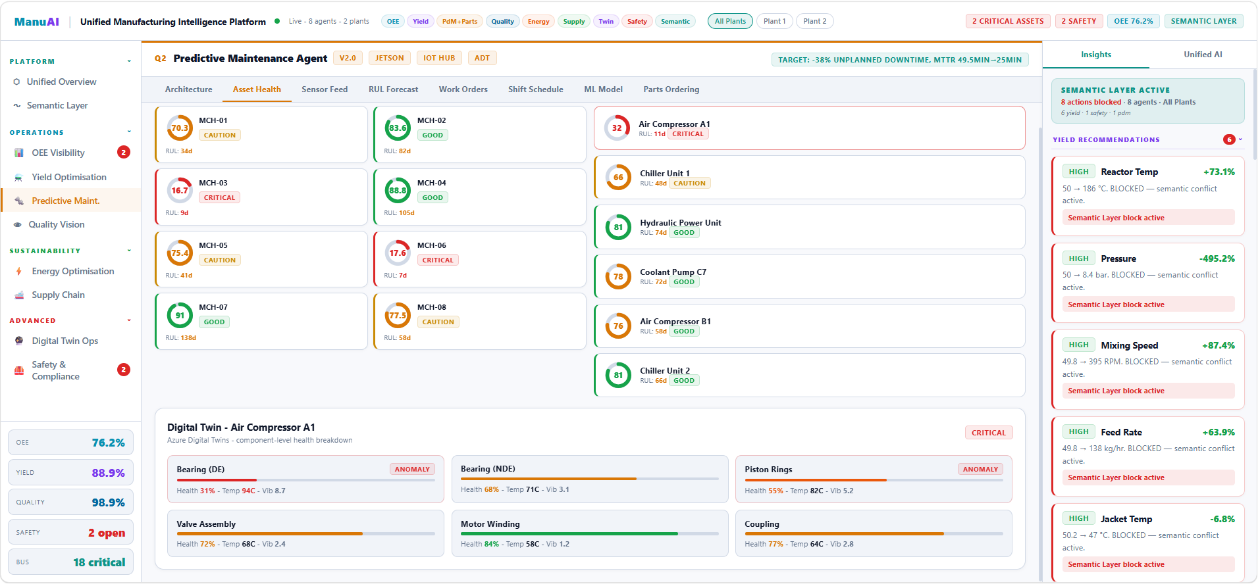
Air Compressor B1:
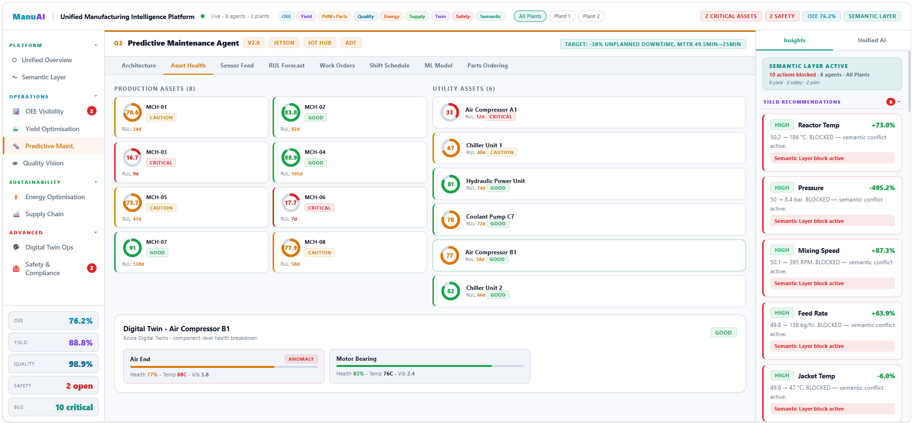

- The current asset naming convention (e.g., MCH-01, MCH-02) is not user-friendly and lacks descriptive clarity. These system-generated codes make it difficult for users to quickly identify and differentiate assets. Instead, asset names should follow a more intuitive and business-friendly format (e.g., Air Compressor A1, Chiller Unit 1) to improve usability, readability, and operational efficiency.



- The Sensor Feed section currently focuses only on vibration data visualization, while other critical parameters such as temperature and pressure are displayed only as numeric values without proper graphical representation. This creates an incomplete monitoring view and limits the ability to analyze trends across all important sensor inputs.

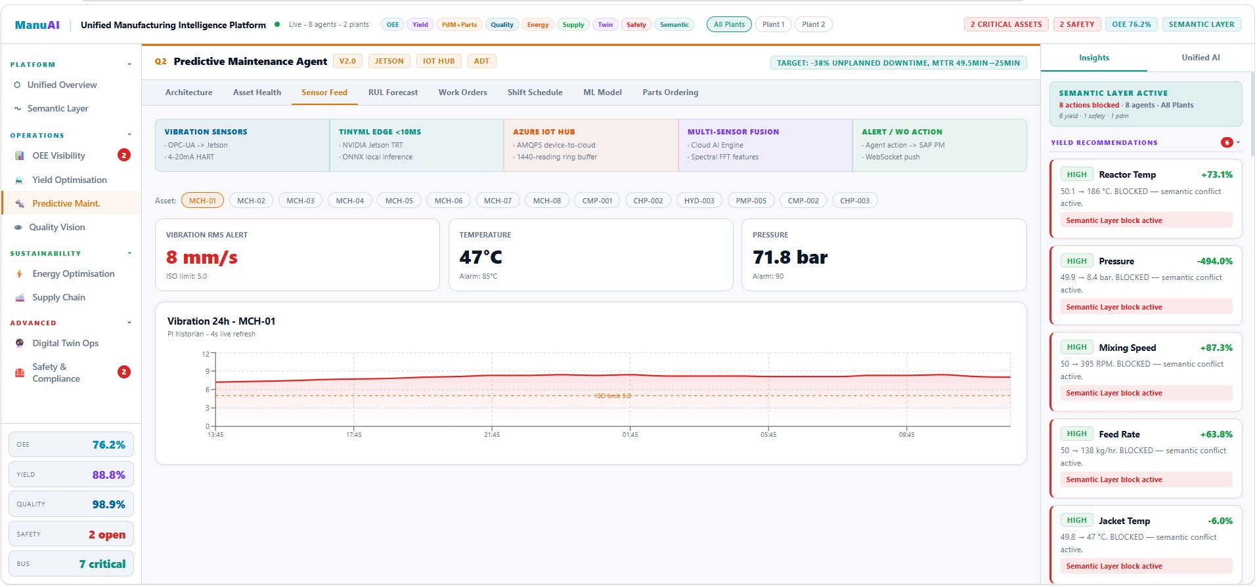

- The RUL (Remaining Useful Life) Forecast section currently displays only a limited set of at-risk assets without providing filtering options based on asset severity. To improve usability and decision-making, the dashboard should include a dropdown filter that allows users to categorize and view assets based on severity levels (e.g., Critical, Warning, Healthy) and analyze their RUL accordingly.

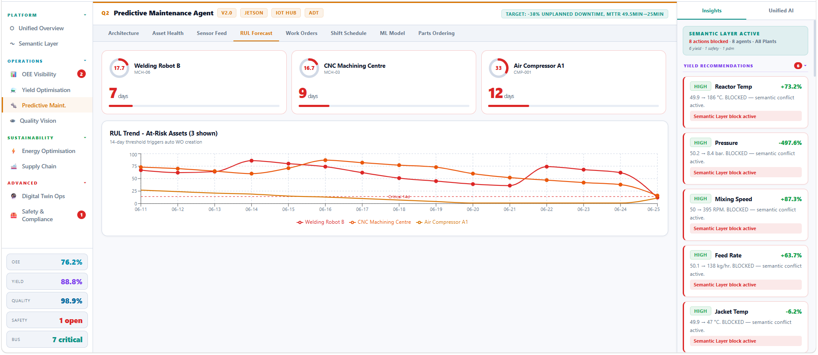

- The Shift Schedule view currently provides only a high-level summary of shifts, showing basic details such as shift name, timing, assigned technician, and count of work orders and assets. However, it lacks detailed visibility into the actual jobs scheduled within each shift.
Users should be able to click on a shift and view detailed information similar to the Work Orders section, including specific tasks, asset details, priority, status, and associated job descriptions.

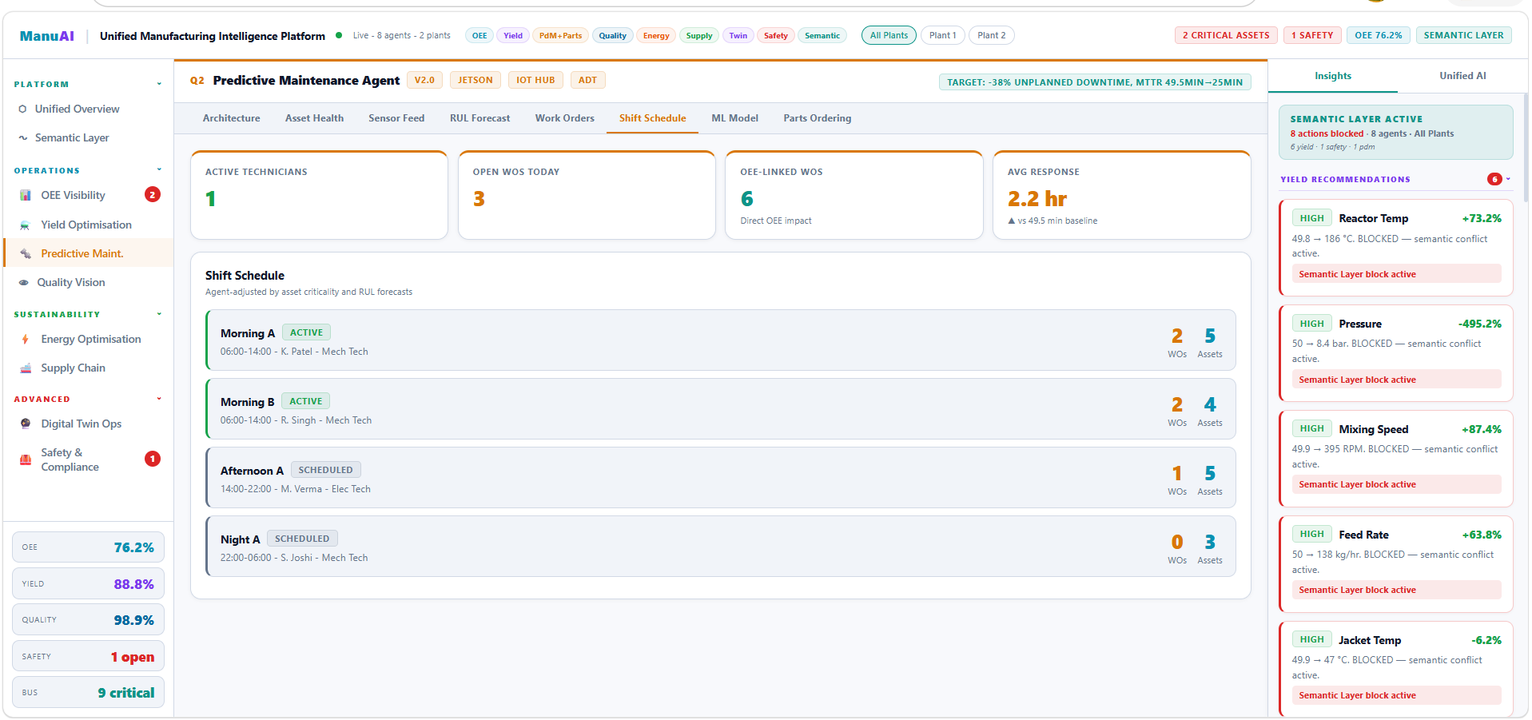

- The KPI cards displayed in the Shift Schedule section (e.g., Active Technicians, Open WOs Today, OEE-linked WOs, Avg Response Time) currently provide only summary-level information. To enhance usability and provide deeper insights, each KPI card should be interactive and open a detailed popup (modal) when clicked, showing a breakdown of the underlying data.


- The KPI cards in the Parts Ordering section (e.g., Orders Today, Needs Approval, Auto-Approved, Unplanned Spend) currently provide only summary-level metrics. To enhance usability and decision-making, each KPI card should be interactive and open a detailed popup (modal) displaying the underlying procurement and supply chain data.

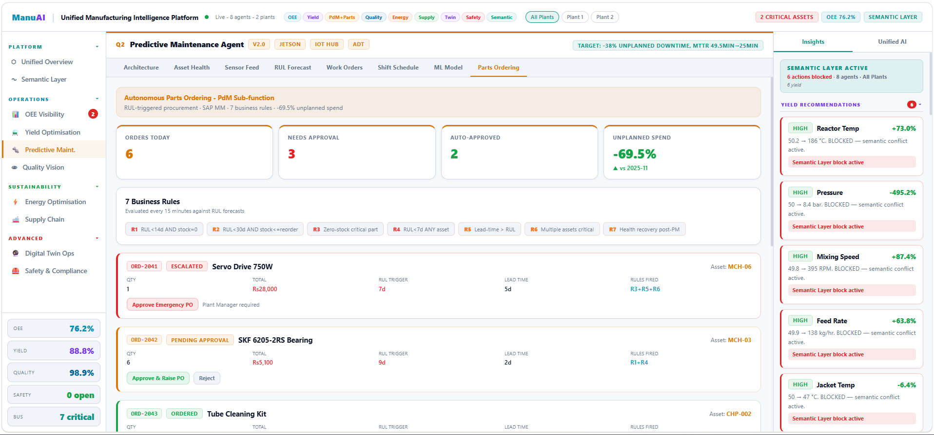

- The dashboard currently lacks critical reliability KPIs such as MTTR (Mean Time To Repair) and MTBF (Mean Time Between Failures). These metrics play a vital role in evaluating maintenance performance, asset reliability, and operational efficiency. Dedicated KPI cards for MTTR and MTBF should be included to provide better visibility and control over maintenance operations.

